# Personal description

In this personal description, I am going to briefly explain what I have done for our group. As an Information System student, I use every modeling skills and analysis methods to help others to improve our website.

Test case:

Based on the user story to test each functions to make sure each functions match the acceptance criteria. Also provide some suggestions to make some better ideas for CS students to program.

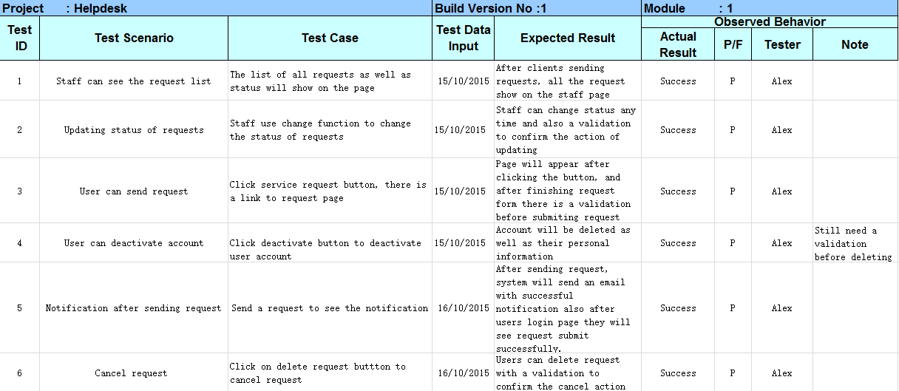

Wrokflow net model:

Based on the modeling skills, by using this model to analyze the process of how our website works, can easily to find which part is the most important part and which part is the basic part. All the functions and process that user and staff will be operated will show on the model. So that CS students can know how to achieve functions in the right way as fast as they can.

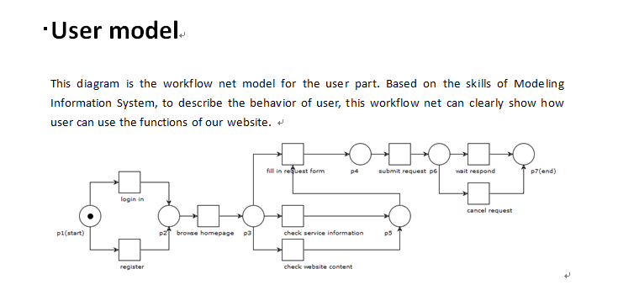

Relationship:

Relationship diagram briefly describe the relationship about three main characters that will involve in our system. This diagram will make us easily understand the scenario and what we need to do and how to implement our website.

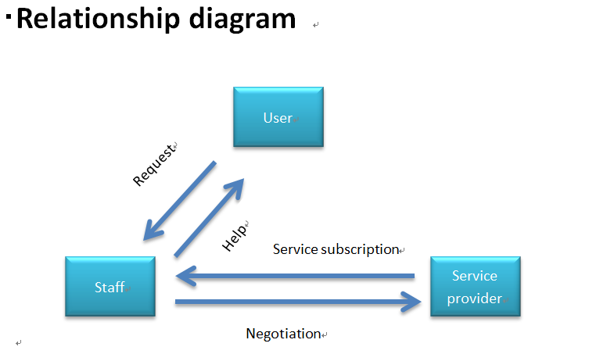

Service information & terms and condition:

I make up all the service information in the user page for user to easily understand what this service is and can get what help.



Presentation slides

I make this presentation slides for the final workshop to demonstrate what we have done during the whole project. This will easily show the achievement to our client.

Peer review: Providing some advices and editing the peer review.